Final Project Proposal - Group 13
MediResolve- Healthcare Management System
Team Members: Anisha Gaikar, Chinmay Sakhare, Pranjal Patil, Shreya Darban.

1. Project Title
Integrated Healthcare Management System – A Multi-Enterprise Patient Care & Coordination Platform

2. Problem Statement
Modern healthcare environments involve multiple independent stakeholders—hospitals, pharmaceutical providers, insurance companies, and regulatory bodies. Each operates in its own silo, using separate systems that do not communicate with each other. This fragmentation makes coordinated patient care significantly more difficult.
Challenges Faced by Patients
- No unified view of complaints, diagnoses, treatments, medications, or insurance claims
- Lack of transparency and real-time updates
- Difficulty navigating complex care processes
Challenges for Healthcare Providers
- Delays in communication between doctors, specialists, and nurses
- Inefficient, manual workflows for diagnosis and treatment
- Poor tracking and management of patient complaints
Challenges for Pharma & Insurance Enterprises
- Lack of coordination between prescriptions, medication fulfilment, and claims
- Slow, error-prone claim handling
- No visibility into ongoing treatments
Challenges for Regulatory Bodies
- Limited oversight across multiple organizations
- Manual audits with insufficient data insights
Why This Matters:
Disjointed systems lead to delayed care, medical errors, poor patient satisfaction, and inefficiencies across healthcare operations. There is a strong need for a unified platform that integrates patient care, complaint management, clinical workflows, medication management, claims, research, and audits.

3. Project Objectives and Goals
Primary Objective
To develop a comprehensive, multi-enterprise healthcare management system that integrates the workflows of hospitals, pharma, insurance, and regulatory enterprises into a seamless ecosystem.
Key Features & Functional Modules
1. Patient Complaint & Vital Management
- File and track complaints
- View vital signs and historical health data
- Provide feedback
2. Clinical Diagnosis & Treatment
- Doctor assessments and diagnoses
- Specialist consultations
- Treatment planning
3. Specialist Consultation
- Review referrals and provide expert opinion
- Manage complex multi-specialist cases
4. Pharmaceutical Management
- Drug catalog access
- Medication order processing
- Interaction checks
5. Insurance Claims
- Automated claim generation
- Claim review and dispute resolution
6. Research & Analytics
- De-identified data for researchers
- Trend analysis and report generation
7. Audit & Compliance
- Quality monitoring
- Regulatory reporting
8. Notification System
- Real-time alerts
- Cross-enterprise communication

4. User Roles and Use Cases
Below are the primary system users and their key use cases.
Role 1: Patient
Use Case 1: Submit & Track Complaint
- File a new complaint with category and description
- Receive real-time status updates
- View complaint history
Use Case 2: Monitor Vital Signs
- View vitals recorded by nurses
- Track health trends over time
Use Case 3: Track Medication Orders & Claims
- Access prescribed medications
- View insurance claim statuses

Role 2: Doctor
Use Case 1: Review & Diagnose Complaints
- View assigned complaints
- Create assessments and diagnoses
Use Case 2: Collaborate with Specialists
- Refer cases
- Review specialist recommendations
Use Case 3: Generate Reports
- Produce patient-level clinical summaries

Role 3: Specialist
Use Case 1: Review Referrals
- Access referrals from doctors
- Evaluate complex cases
Use Case 2: Provide Expert Consultation
- Document specialist diagnosis
- Recommend treatments

Role 4: Scientist/Researcher
Use Case 1: Conduct Research
- Access anonymized patient and complaint data
Use Case 2: Generate Analytics Reports
- Identify trends in complaints, diagnoses, outcomes

Role 5: Pharmacist
Use Case 1: Fulfill Medication Orders
- Process prescriptions
- Check drug interactions
Use Case 2: Manage Drug Catalog
- Update drug details and inventory

Role 6: Auditor
Use Case 1: Monitor System Quality
- View system-wide dashboards
Use Case 2: Conduct Compliance Audits
- Review workflows and documentation

5. System Architecture and Design Approach
The system follows the AED multi-enterprise ecosystem architecture.
Ecosystem Layout
- Ecosystem
  - Network
    - Hospital Enterprise
      - Doctor Organization
      - Specialist Organization
      - Nursing Organization
      - Research Organization
    - Pharma Enterprise
      - Pharmacist Organization
    - Insurance Enterprise
      - Claims Processing Organization
    - Regulatory Enterprise
      - Auditor Organization
Design Approach
- Network-centric enterprise architecture
- Role-based access control (RBAC)
- Directory-based data management (ComplaintDirectory, DrugCatalog, ReportDirectory, etc.)
- State-driven workflows using WorkQueues and WorkRequests
- Modular design for scalability and separation of concerns
- Model (business classes), view (UI panels), and controllers (actions)

6. Object Model (UML Class Diagram)
Ecosystem Hierarchy Diagram 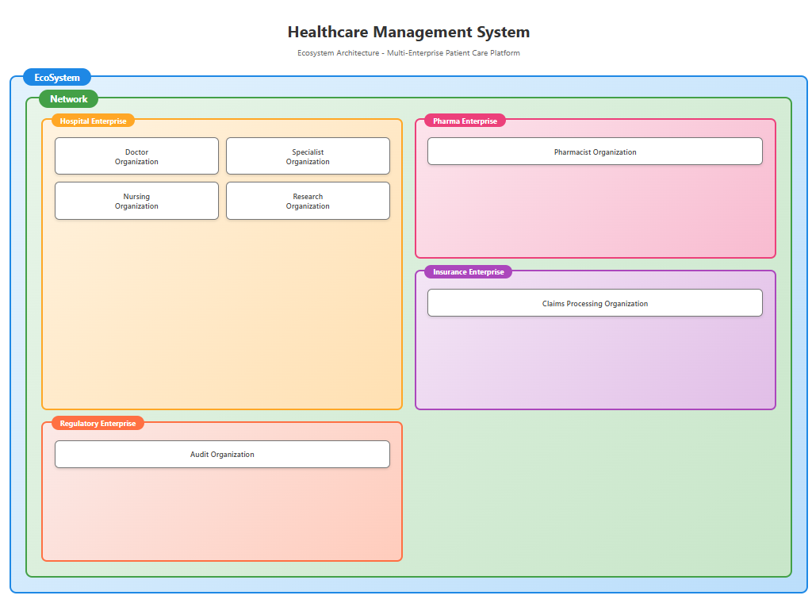
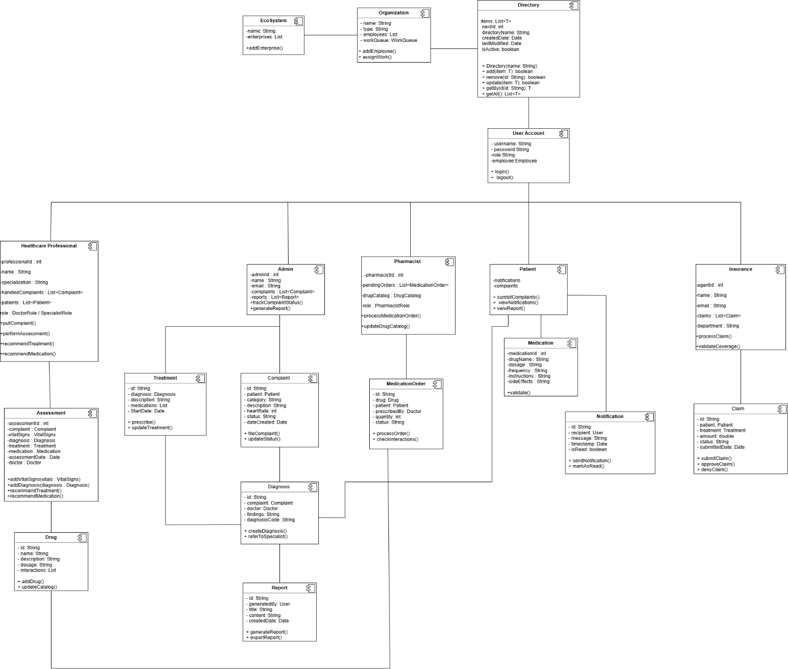
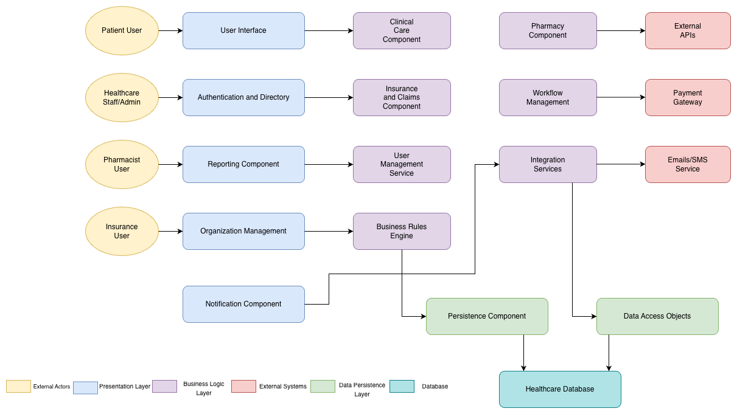
Key Classes
- User, Patient, Doctor, Specialist, Scientist, Pharmacist, Auditor
- Complaint, VitalSigns, Diagnosis, Treatment
- Drug, MedicationOrder, Claim
- Notification, Report
- Organization, Enterprise, Network, EcoSystem
- Corresponding Directories

7. Data Input and Output
Inputs
- Patient: Complaint forms, feedback, symptoms
- Doctor/Specialist: Assessments, diagnoses, treatment notes
- Nurse: Vital signs
- Pharmacist: Medication fulfillment
- Insurance Processor: Claim approvals/denials
- Auditor: Compliance notes
Outputs
- Complaint status updates
- Vital signs trends
- Treatment summaries
- Medication status
- Insurance claim outcomes
- Research reports
- Audit dashboards
- Cross-enterprise notifications

8. Implementation Plan & Timeline
Week / Dates | Milestones & Deliverables
Week 1 (Nov 21 – Nov 24) | • Finalize all requirements and use cases  • Complete high-level system architecture  • Create UML diagrams (Ecosystem, Enterprises, Class Diagrams)  • Set up GitHub repository and initialize project structure
Week 2 (Nov 25 – Nov 30) | • Implement core EcoSystem, Network, Enterprise, and Organization classes  • Set up UserAccount, Employee, and Directory classes  • Implement Login functionality with role-based access panels (Patient, Doctor, Specialist, Pharmacist, Scientist, Auditor)
Week 3 (Dec 1 – Dec 3) | • Implement Patient workflow (complaints, vitals, feedback)  • Implement Doctor workflow (assessment, diagnosis, specialist referral)  • Implement Specialist workflow (advanced review and expert diagnosis)
Week 4 (Dec 3 – Dec 5) | • Implement Pharma module (drug catalog, medication orders)  • Implement Insurance claims module  • Implement Research, Audit, and Notification modules  • Perform full system integration and testing  • Prepare project presentation and demonstration materials

9. Assumptions & Limitations
Assumptions
- Users belong to one healthcare network
- Proper credentials and authorization are provided
- Input data is accurate and validated
Limitations
- No external database (local storage only)
- Swing UI (not mobile-responsive)
- No real-time medical algorithms
- Insurance and pharma workflows simplified

10. Suggested Improvements
1. Twilio API (SMS & Email Alerts)
- Sends automated notifications regarding complaint updates, prescription readiness, and appointment reminders.
- Sandbox mode enables safe testing without sending real SMS or emails.
- Enhances real-time communication between patients, doctors, and pharmacists.
2. OpenFDA Drug Information API
- Automatically retrieves live drug details, warnings, and side effects.
- Keeps the pharmaceutical module and drug catalog dynamically updated with accurate information.
- Useful for medication safety checks and data verification.
3. SQL Database Integration
- Future versions can integrate MySQL or PostgreSQL for persistent, structured storage of patients, complaints, medications, and claims.
- Enables multi-user access, scalable data management, and realistic enterprise performance.
- Supports advanced querying and reporting, making the system production-ready.
4. Advanced Analytics and Reporting
- Integrates analytical dashboards for complaint trends, treatment outcomes, wait-time analysis, and medication effectiveness.
- Enables data-driven decision making for doctors, specialists, pharma teams, and auditors.
- Supports exporting research reports, audit summaries, and performance charts for regulatory compliance and quality improvement.
- Lays the foundation for predictive analytics (e.g., identifying high-risk patients, forecasting medication demand).

